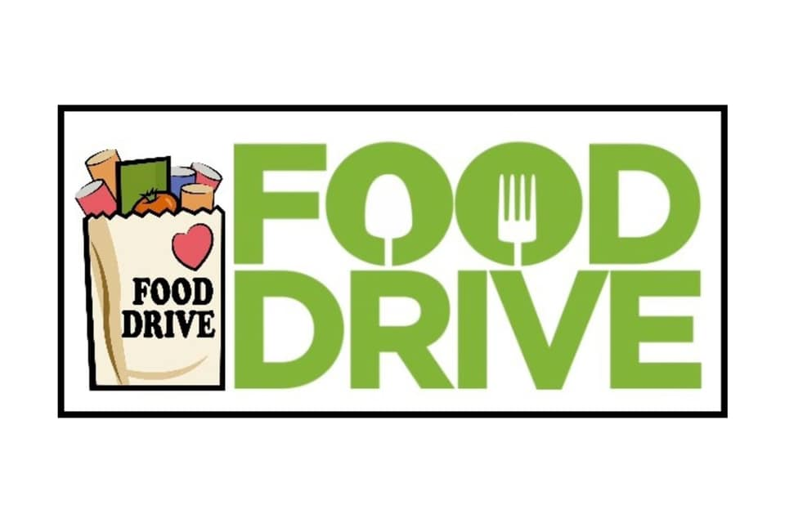

Please join (your name/organization) in collecting food for the Backpack Crew. The Backpack Crew is a local organization that began, in 2013, by providing children with weekend meals when they do not have school lunch on which to rely. Since then, they have expanded to offer weekly Food Pantries, at multiple locations, to anyone who is in need. Your contribution is greatly appreciated!

Making a donation is easy! Just leave (your donation) on (event date/time) at (designated location front porch/mailbox/etc.) and we’ll deliver it to the Backpack Crew!

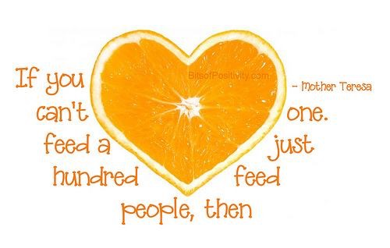

For more information on the Backpack Crew or its services, or to make a monetary donation, please visit https://backpackcrew.org or on Facebook and Instagram: thebackpackcrew:

